**ASSISTED PRACTICE (TIMER IS SYNCHRONIZED IN JMETER)**

Step1: Take the same Thread Group as of Constant Timer

Step2: In Thread Group, Give the values as shown below:

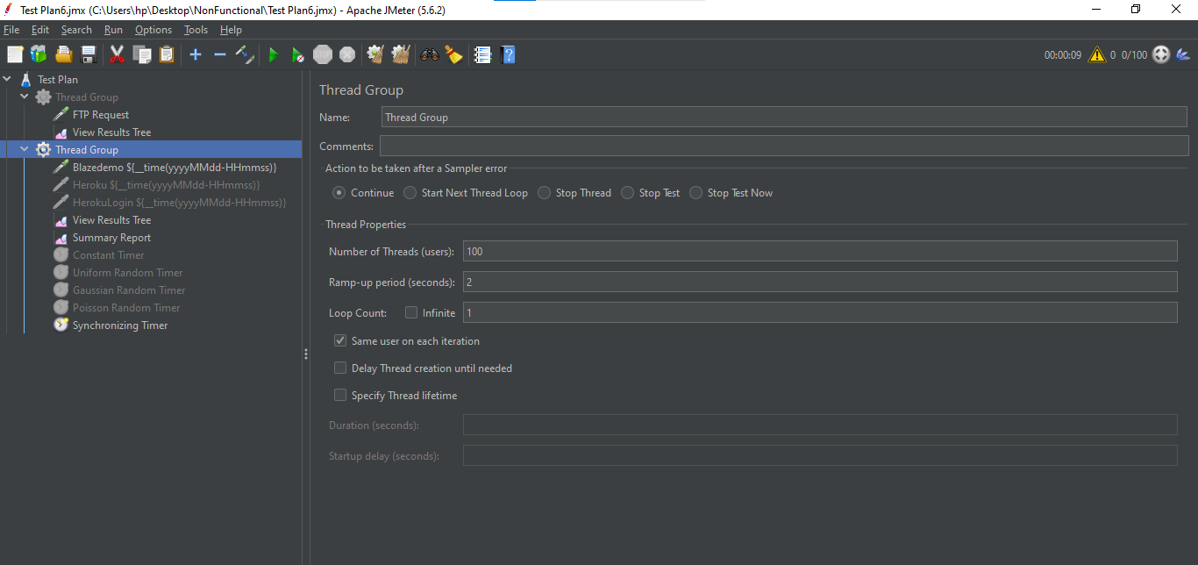

Step3: Disable all the previously added Timers -> Also disable second and third HTTP Request

Step4: Right click on Thread Group -> Add -> Timer -> Synchronizing Timer

Step5: In Synchronizing Timer, Give the values as shown below:

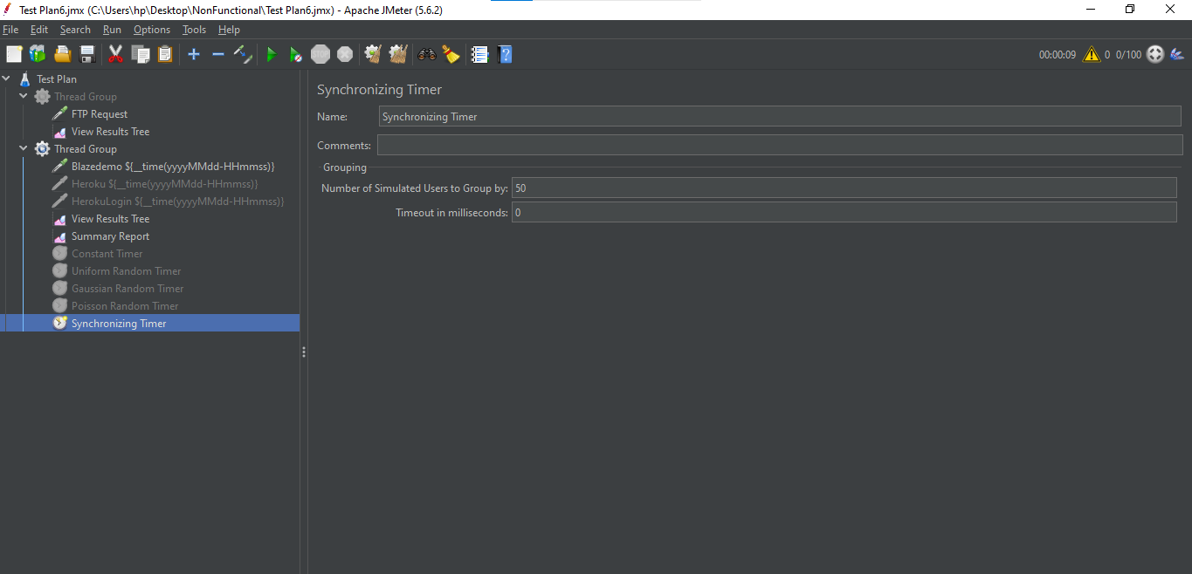

Step6: Save it and execute to see the output

In View Results Tree:

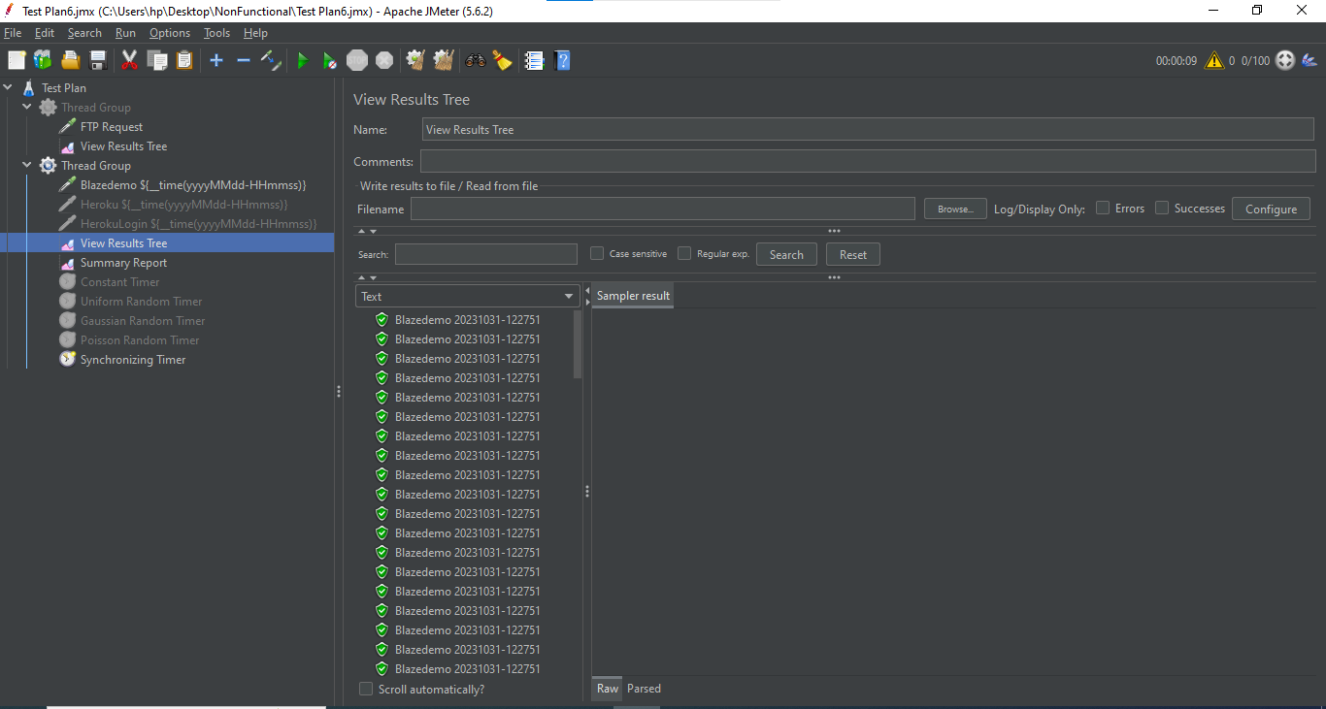

Summary Report:

